NAME: JAMILA ALI
SUPERVISOR: FRANCIS YEGO
PROJECT: PREDICTING EMPLOYEE ATTRITION USING MACHINE LEARNING.

ABSTRACT.
Background
Human resource managers plan, coordinate, and direct the administrative functions of an organization. They recruit, interview, hire new staff; consult with top executives on strategic planning; and serve as a link between an organization's management and its employees. They also conduct disciplinary actions, maintain employee records and conduct benefit analysis. With the knowledge of machine learning we are able to predict employee attrition which benefits both the employer and employee. Our objective in this project is to determine factors that contribute to employee attrition in the company, compare various ML models in predicting employee attrition and propose optimal models that can be used to predict employee attrition.
OBJECTIVES.
To predict employee attrition.
To see whether machine learning models can give accurate prediction.

Methods
In this project we are going to use the HR comma dataset and use machine learning models. We are going to use machine models like Logistic regression, Random forest, Gradient boosting and Decision Tree for classification. The models were then combined to see the most accurate model capable of giving the best result.
Results
Based on the results we can see that Random Forest is the best model to be used in this project because it has a higher recall score than the other models. It has a recall score of 0.9729425028184893 and a ROCAUC of 99%. This shows that the random forest regressor is the best model and it gives the accurate prediction.
Conclusion
Through the analysis, I concluded that machine learning models can provide an accurate identification for employees who have the possibilities of being attrited.

INTRODUCTION

Background
HR emerged as a specific field in the early 20th century, influenced by Frederick Winslow Taylor (1856–1915). Taylor explored what he termed "scientific management" (sometimes referred to as "Taylorism"), striving to improve economic efficiency in manufacturing jobs. Human resource management (HRM), also called personnel management, consists of all the activities undertaken by an enterprise to ensure the effective utilization of employees toward the attainment of individual, group, and organizational goals. An organization's HRM function focuses on the people's side of management. It consists of practices that help the organization to deal effectively with its people during the various phases of the employment cycle, including pre-hire, staffing, and post-hire. The pre-hire phase involves planning practices. The organization must decide what types of job openings will exist in the upcoming period and determine the necessary qualifications for performing these jobs. During the hire phase, the organization selects its employees. Selection practices include recruiting applicants, assessing their qualifications, and ultimately selecting those who are likely to be the most qualified. I used machine learning models with the HR Dataset to predict employee attrition.
Data
Human resource management has datasets to help them know whether the employees are staying or given a retrenchment. They analyze their data and predict their results using machine learning models so that companies do not lose skilled employees or their employees to be ready and aware if there is any attrition. The HR Dataset provided gives the researchers or scientists a chance to predict employee attrition.

METHODOLOGY
a) Data
b) Data Pre-processing
c) Statistical Analysis.
d) Predictive Analysis.
e) Machine Learning.
f) Exploratory Data analysis

Data
I started by extracting my data then I explored through my data. I looked for their dtypes and found out there are only two objects in my dataset which are sales and salary. Then I looked through its description and learned all the columns. My dependent value is left which is an integer. My prediction is to determine whether one is going through attrition or they are staying. I used one hot encoding to convert categorical data to numerical for analysis. Next, I clean the data by checking for outliers. I checked for outliers and dropped them using the filter method. Then I check for duplicates using the data frame name is equal to df. duplicated. sum (). We found out that there are 2717 duplicated values. Then we have to drop the duplicated values by using a data frame. drop duplicate values to remove the duplicates. After cleaning the dataset, we visualize it. I also grouped by using left which was the dependent variable. I used the robust scaler for classification.
MODEL DEVELOPMENT
The dataset splits into t-test and train test for comparison. In the training phase of model development, the training dataset uses classifier machine learning models for the prediction because the dataset is categorical because one can either be attrition or stay. In the validation phase, the models were tested with the features of the testing dataset to evaluate them on how well they can conduct a prediction.

Machine Learning Models
During my study, I used multiple supervised learning models for classification. Supervised machine learning is defined by its use of labelled datasets to train algorithms that classify data or predict outcomes accurately that contain both the recorded observations and corresponding labels for the category of the observations.
My machine learning models used were;
a) Logistic Regression
Logistic Classifier is a Machine Learning algorithm which is used for the classification problems, it is a predictive analysis algorithm and based on the concept of probability. The hypothesis of logistic regression tends to limit the cost function between 0 and 1.

b) Random Forest
Random Forest Classifier is a supervised learning algorithm that uses ensemble learning method for classification. A Random Forest operates by constructing several decision trees during training time and outputting the mean of the classes as the prediction of all the trees.
c)Gradient boosting
d)Decision Tree
A decision tree is a support tool with a tree-like structure that models probable outcomes, cost of resources, utilities, and possible consequences. Decision trees provide a way to present algorithms. They include branches that represent decision-making steps that can lead to a favourable result.
EVALUATION METRICS
Metrics used to evaluate on the test size were accuracy score, Recall score, precision score, f1_score and area under ROC curve. ‘‘Metrics play a significant role in quantifying performance and improving efficiency of models’’ (Flach 2003).
- True positive: is when the prediction value is positive the results turn out to be true e.g. When the prediction says that one is going for an attrition and the person actually gets an attrition.
- False positive: is when the values are predicted as positive and turns out to be false e.g. When one is predicted to have an attrition but in real one does not get an attrition.
- False negative: is when values are predicted as negative and turns out to be false. e.g. When one is predicted to not have an attrition but ends up with an attrition.
- True negative: is when the prediction value is negative the results turn out to be true. e.g. When the prediction is that the employee is not having an attrition and the results are true.
ROC AUC checks performance of classification problems at different levels. ROC AUC is used to compare and evaluate the discrimination power of machine learning models (Rodriguez and Rodriguez 2006).
It shows the extent of the model’s capability to distinguish between classes (Bowers and Zhou 2019).
Graphs above show ROC AUC curves which show how the predictive models used will be able to differentiate between the true positives for each of the trained models tested.
From the graphs above, random forest and gradient boost has the highest ROC AUC (99%), followed by decision Tree (98%) and lastly logistic regressor with (81%).

EXPLORATORY DATA ANALYSIS (EDA)
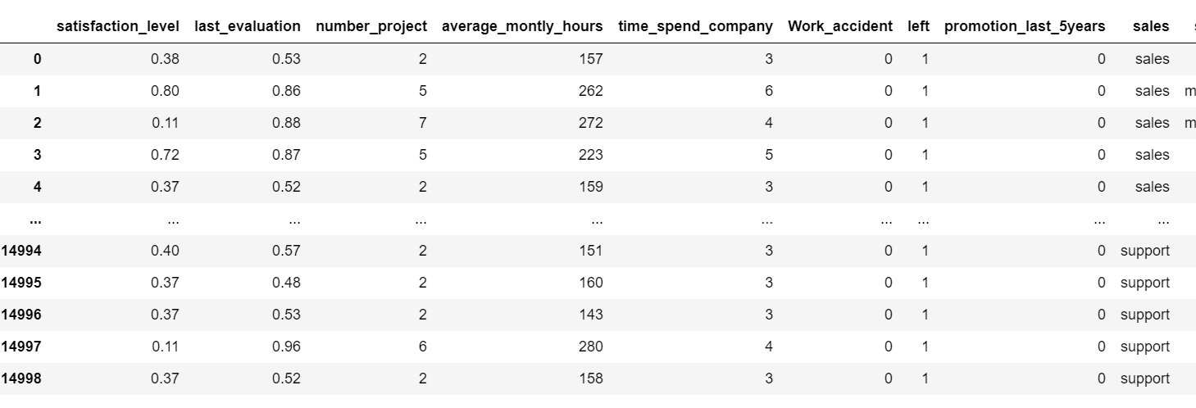

Exploratory Data Analysis
LEFT (Attrition)

=
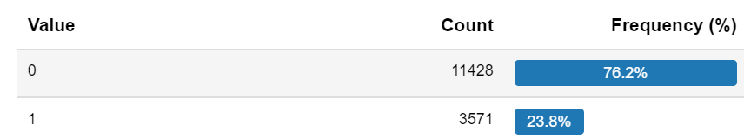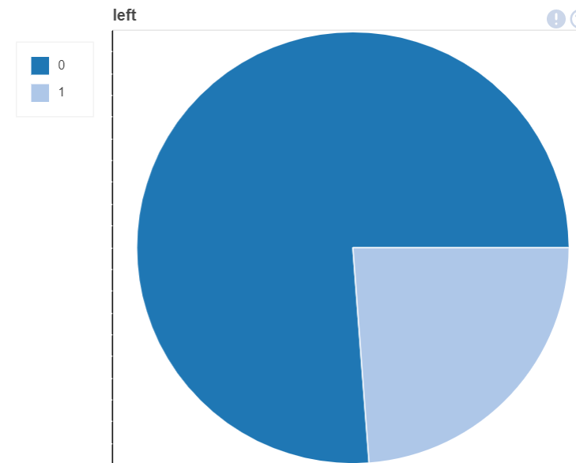
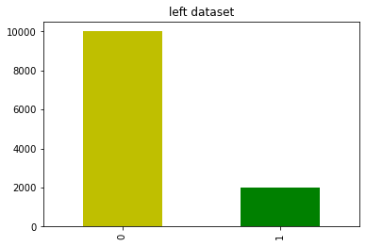
From above we can see the attrition rate is low since the number of employees who have left are few (23.8%) compared to those who remained (76.2%).
LAST EVALUATION

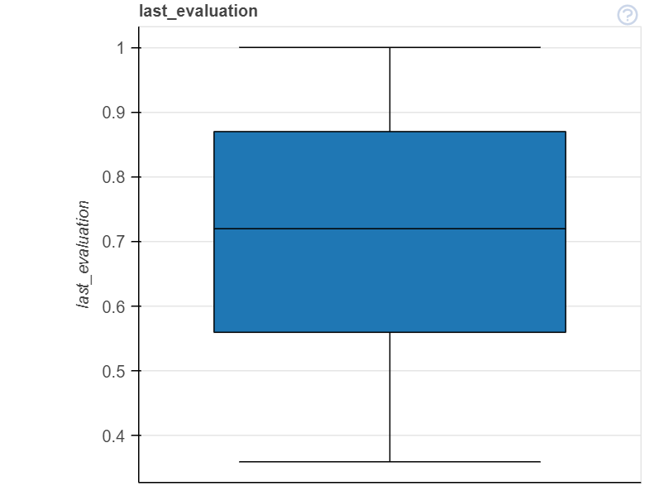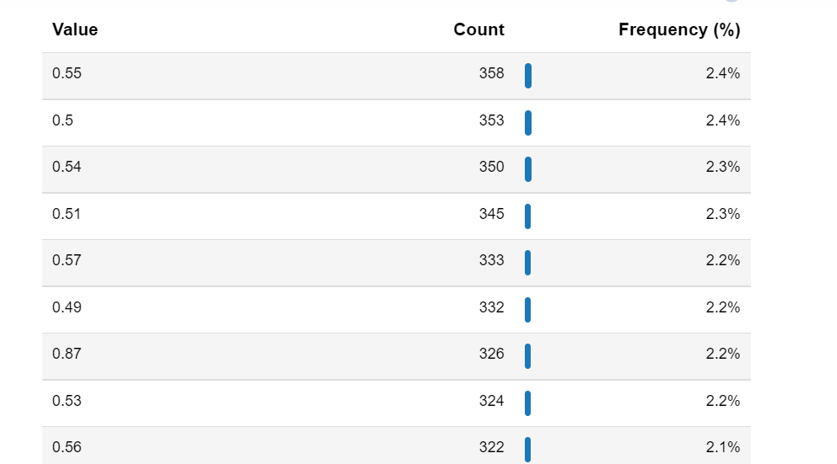
From the above data we can see that the maximum value count in the last evaluation is 2.4% and value of 0.55 while the low maximum value count is 2.1% with a value of 0.56.

SATISFACTION LEVEL
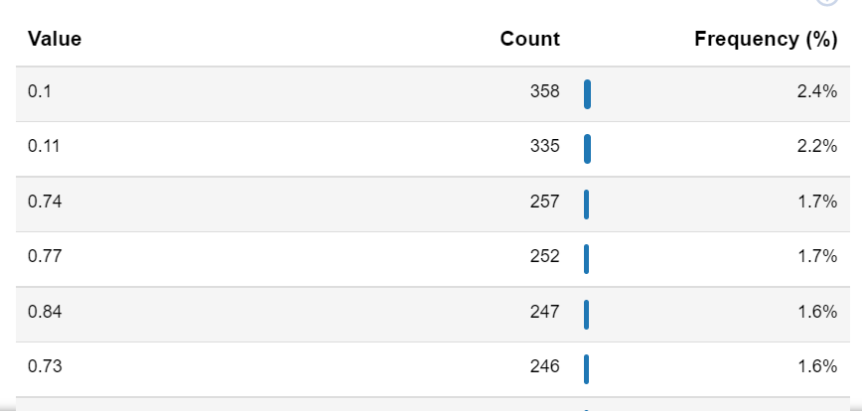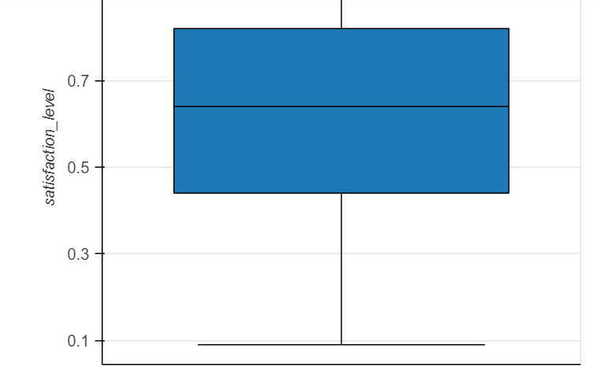
For the satisfaction level its highest frequency is 2.4% and its lowest frequency is 1.6% and the highest value is 0.1 and lowest is 0.73.

DEPARTMENT
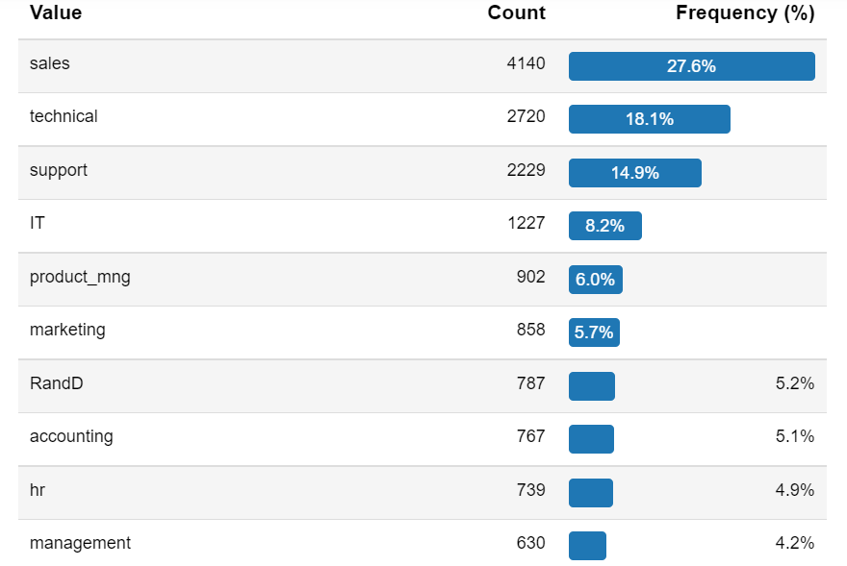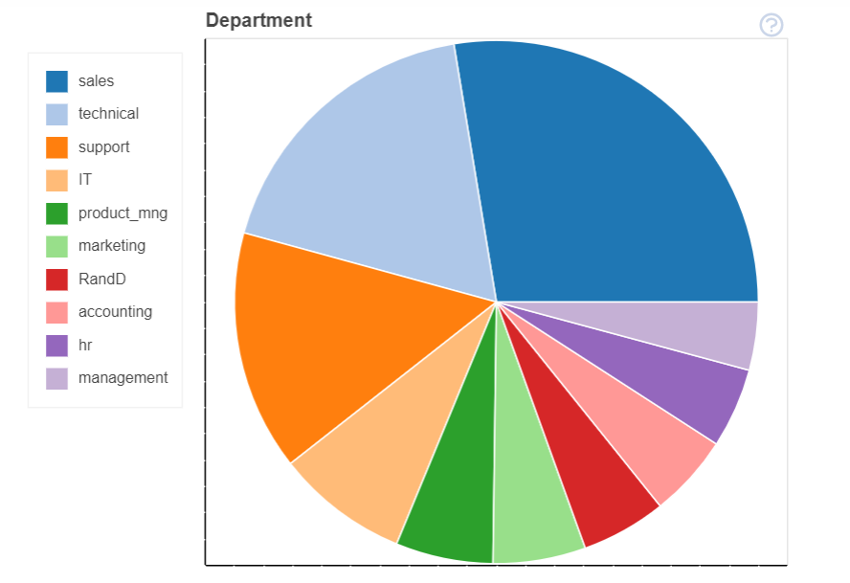
From the table above, the one with the highest frequency is sales with a frequency of 27.6% and management is the lowest with percentage frequency of 4.2%.

PROMOTION LAST 5 YEARS
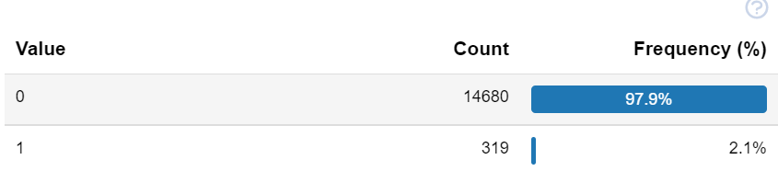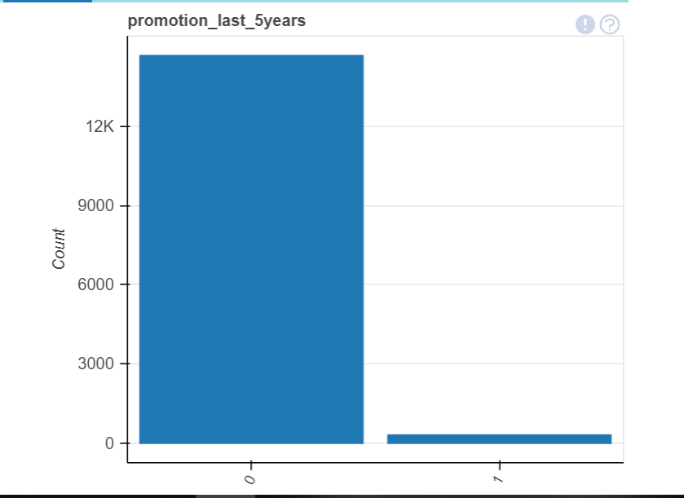
The employees who had been promoted in the last 5 years were likely to stay while those who were not promoted had a high chance of going through an attrition.

AVERAGE MONTHLY HOURS
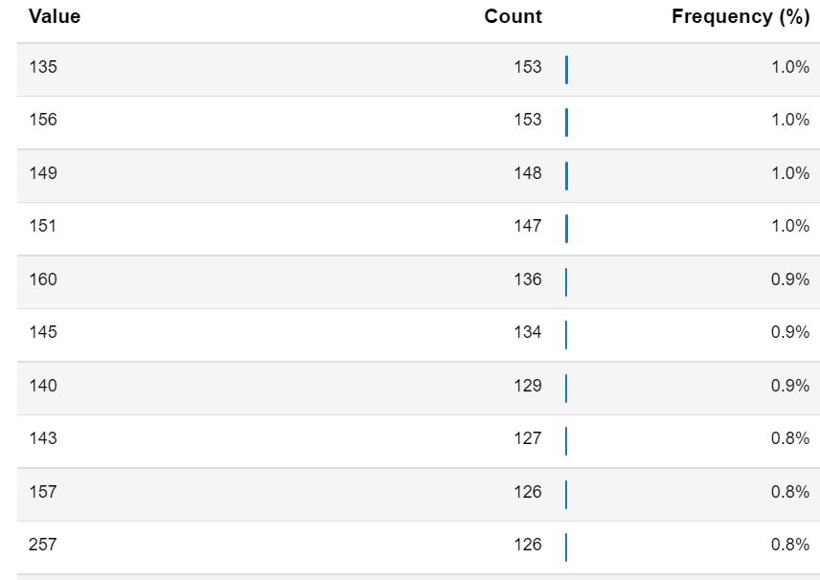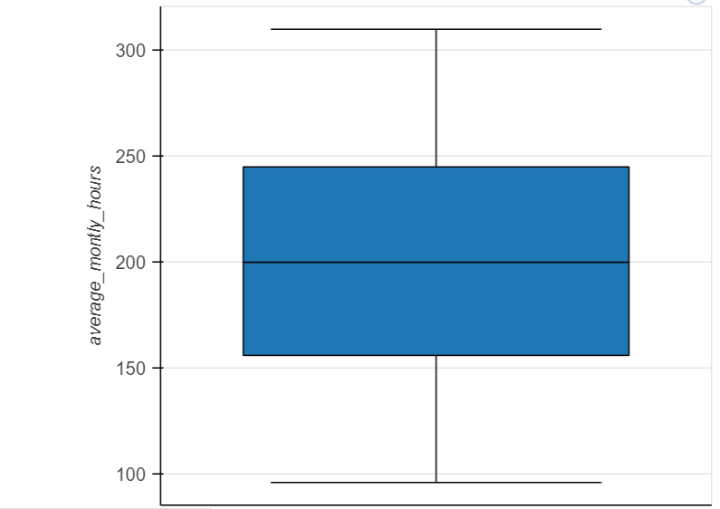
Those who were spending more time working were likely to go through an attrition. The highest frequency was 1.0% with a value of 135 while the lowest frequency of 0.8% with a value of 257.
TIME SPENT IN THE COMPANY
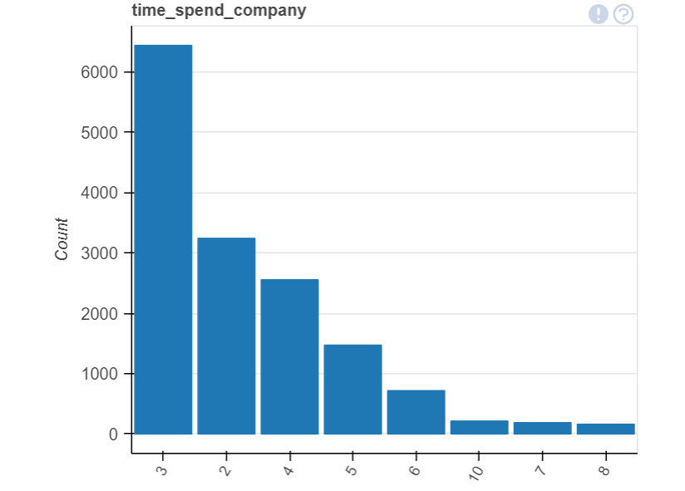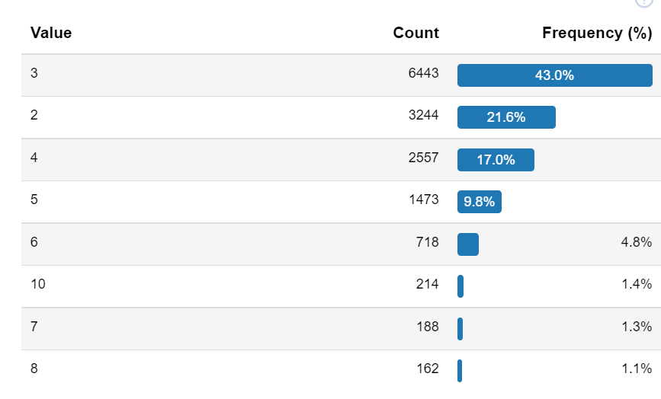
Those who have spent a lot of time in the company were not likely to be up for an attrition. The highest frequency is 43.0% while the lowest frequency is 1.1% where by the employees with the frequency were likely for an attrition.

WORK ACCIDENT
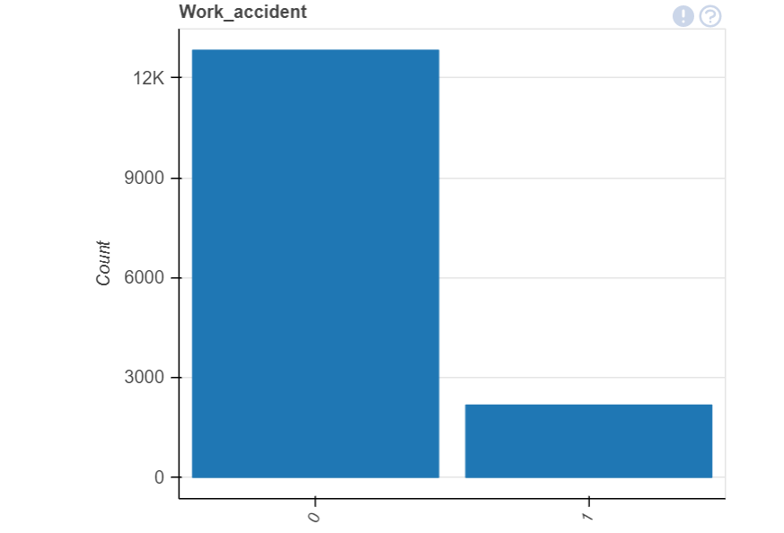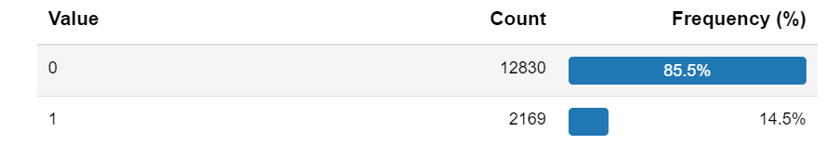
The employees that were going through an attrition did not have a lot of work accidents. Their frequency was 85.5% while those who are staying had a frequency of 14.5%.

NUMBER OF PROJECT
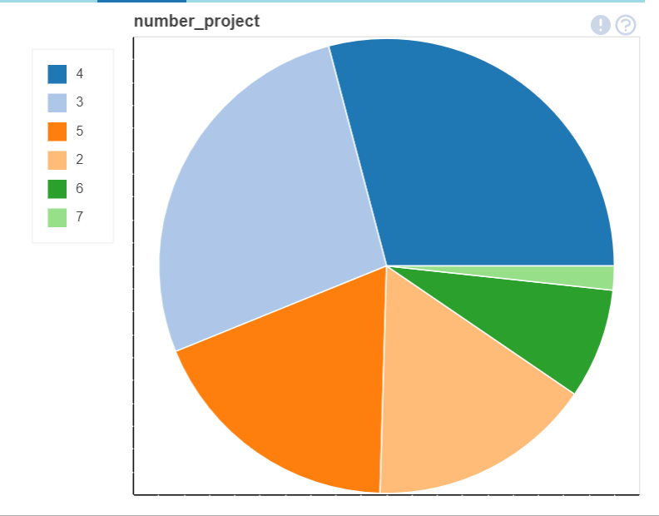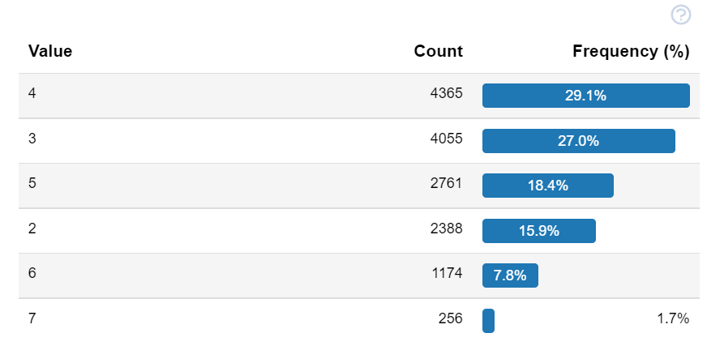
Those with the highest no of projects were not likely to go for an attrition .The ones we the highest frequency was 29.1% with a value count of 4 while the lowest was 1.7% with a value count of 7.

SALARY
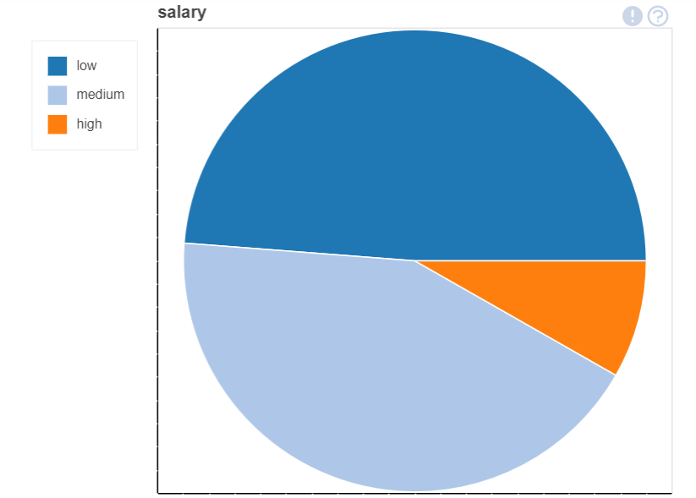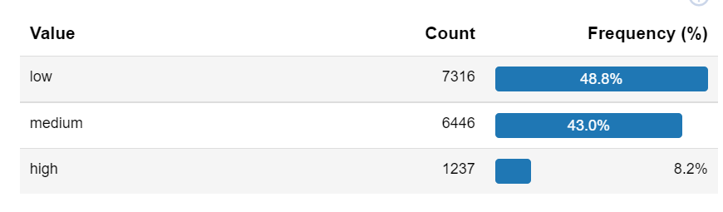
As we can see of the pie chart those with a low salary were likely to go for an attrition while those with a high salary were staying. The one with the highest frequency is low with a frequency of 48.8% while those with a high salary had a frequency of 8.2% .

SHOWING CORRELATION.
I used heatmap to show correlation.
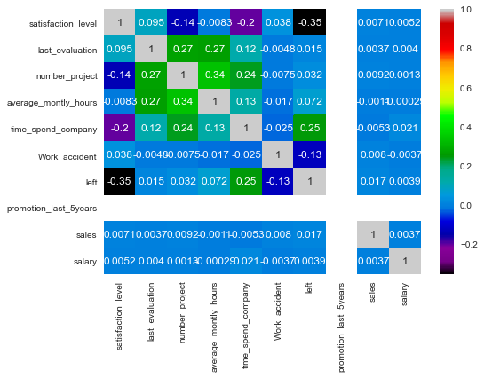

DATA PREPROCESSING
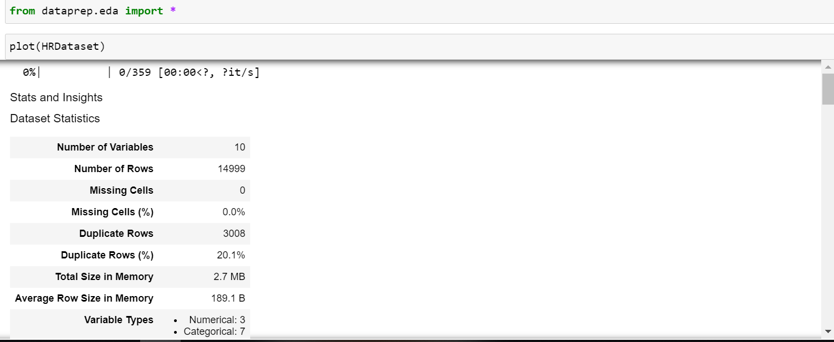
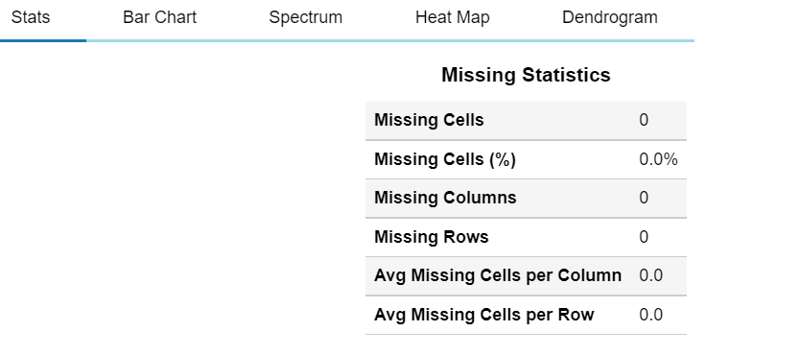
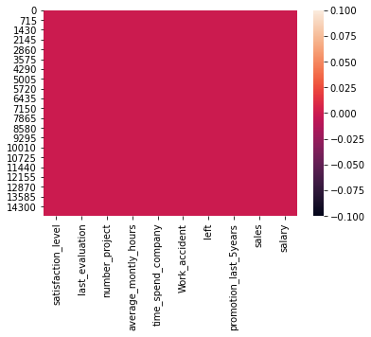
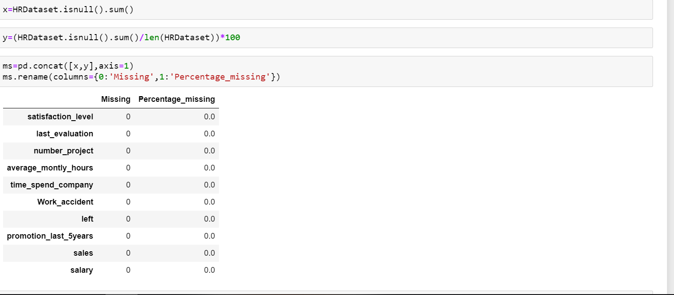
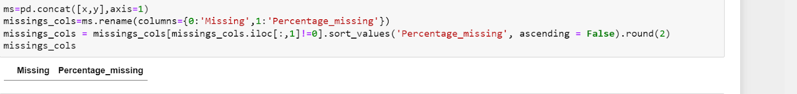
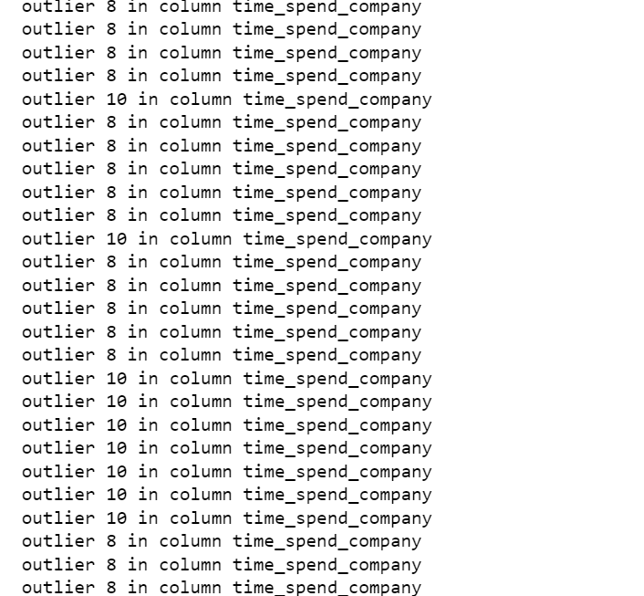
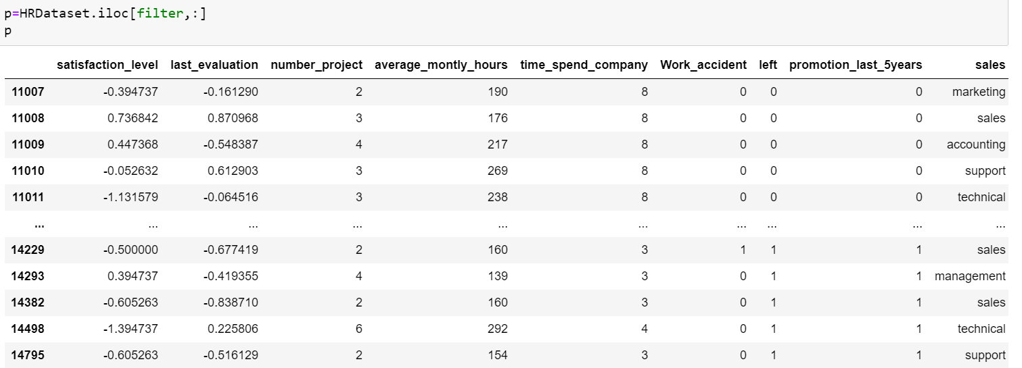
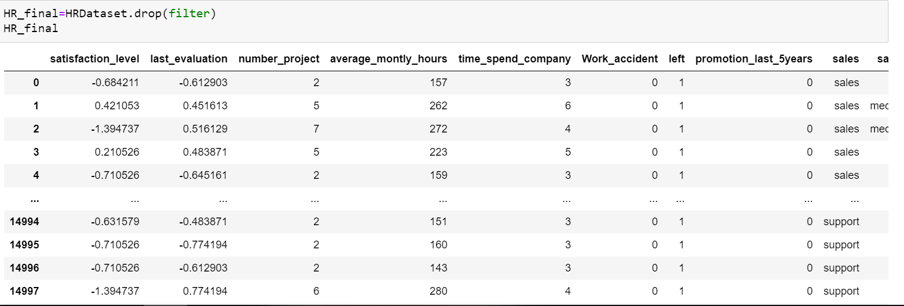
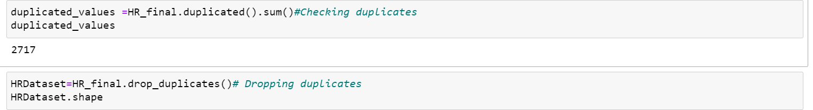

FEATURE ENGINEERING
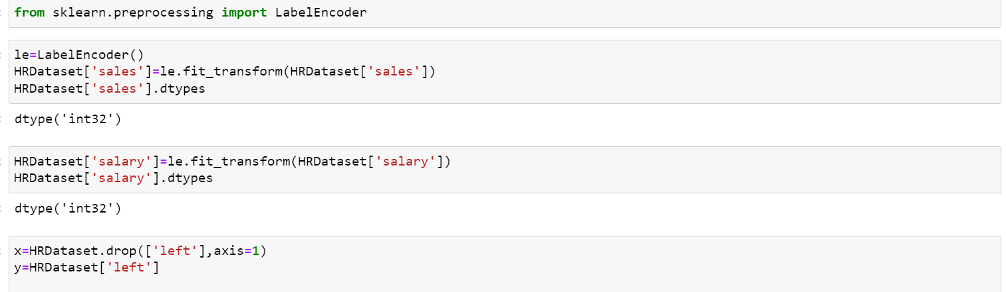I used a label encoder because it is categorical data. I used label encoder to transform salary and sales which are objects to integers.

FEATURE SCALING
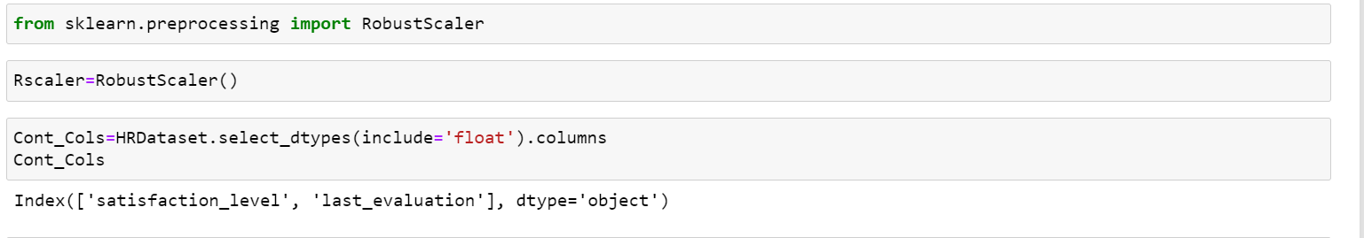

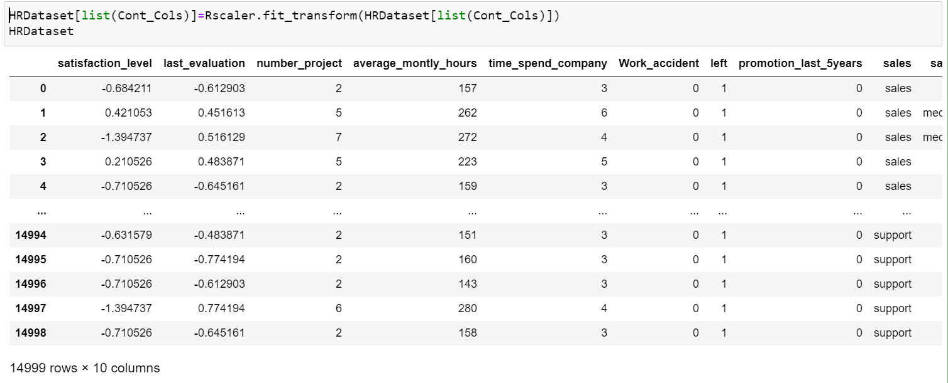

DATA VISUALIZATION.
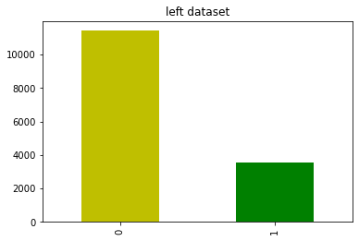
This shows that few employees are going to be retrenched due to the low count value for the probability of the ones attrited which has a value count of 4000 while the other one has a value count of 15000 which is high. I used the bar graph to plot the Dataset using value counts.

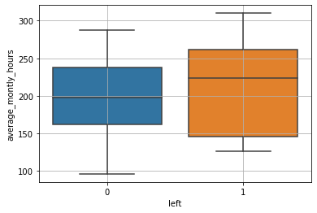
I used boxplot to plot the dependent value and average monthly hours. I found out that the outliers were dropped and there were no outliers. The people with high chances of leaving are having an average monthly hour between 140 to 260 while those who are not likely to leave have an average monthly hour of between 160 and 260.This shows that the ones with high average monthly hours are likely to retrenched.

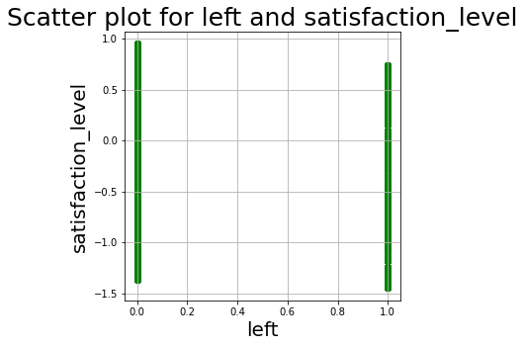
Plotted using scatter plot for left and satisfaction level. Those who are likely for attrition have a lower satisfaction level than those who are not likely for attrition.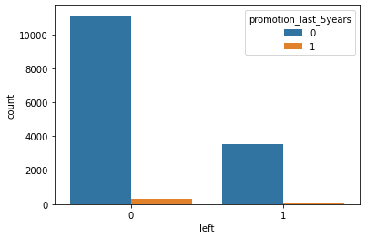
The employees who are not likely for an attrition have a high number of employees who were promoted for the last 5 years. This shows that most employees with promotions are not likely to be retrenched, maybe due to their good work in the working area.

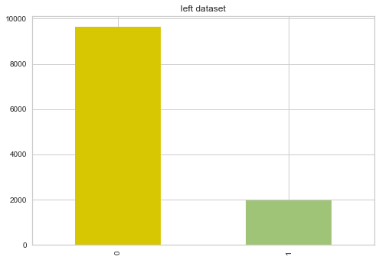
The people who stayed have a value of above 2000 to 9000 while those would go through an attrition had a value count of below 2000.
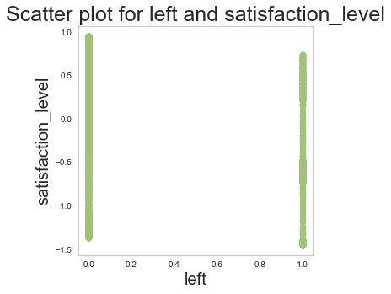
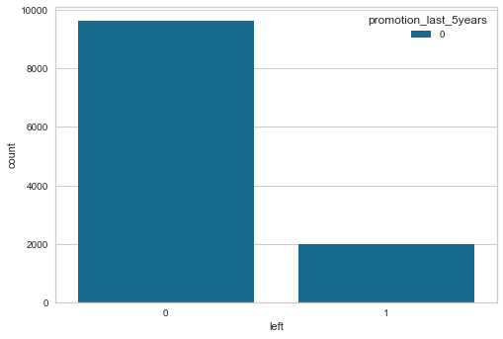
The who stayed have a higher count of promotion over the last five years while those who are leaving have a low number of people promoted.
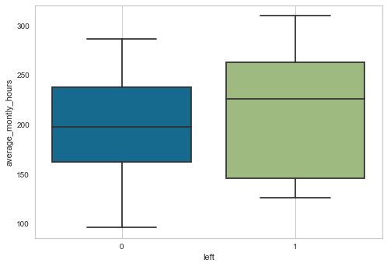
The ones leaving have a higher rate of average monthly hour between 150 and 260 while those staying have low average monthly hours of between 170 and 240.

RESULTS AND DISCUSSION

Machine Learning Models | Recall Score | F1 Score | Accuracy Score | Precision Score
Decision Tree | 0.9695603156708005 | 0.9550249861188228 | 0.9784 | 0.9409190371991247
Random Forest | 0.9729425028184893 | 0.9834757834757835 | 0.9922666666666666 | 0.9942396313364056
Logistic Regression | 0.25591882750845546 | 0.34789272030651336 | 0.7730666666666667 | 0.5430622009569378
Gradient Boosting | 0.9357384441939121 | 0.9545715928694652 | 0.9789333333333333 | 0.9741784037558685
From our table we can see that the Decision Tree Classifier gives the best results with the highest number of recall scores than the other models.
ROC COMPARISONS.
ROC AUC OF LOGISTIC REGRESSION.
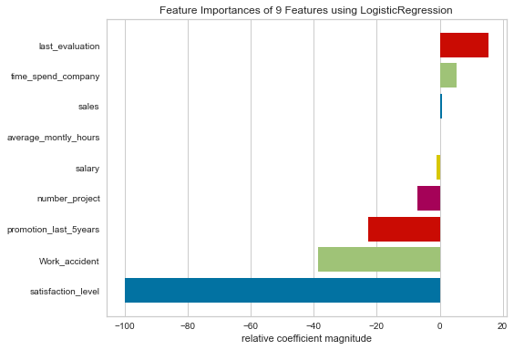
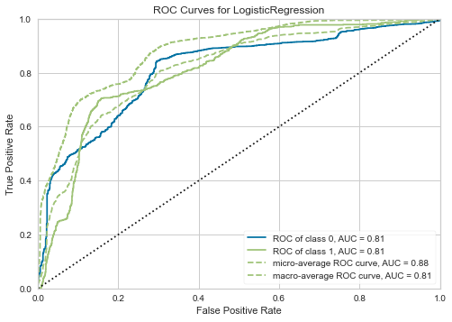

ROC AUC OF RANDOM FOREST CLASSIFIER.
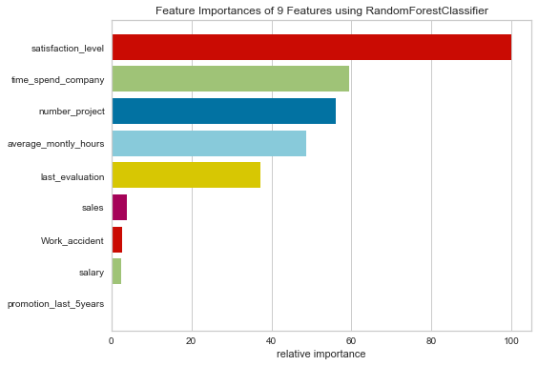
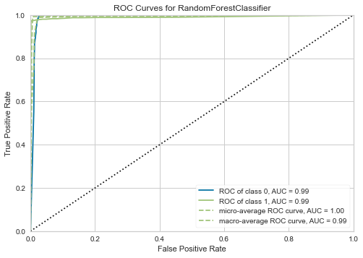

ROC AUC OF GRADIENT BOOST CLASSIFIER.
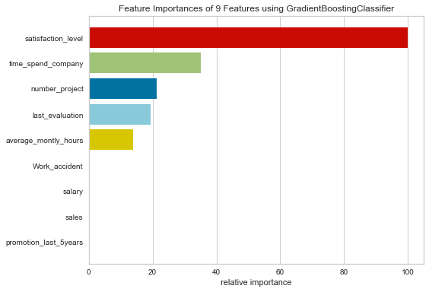
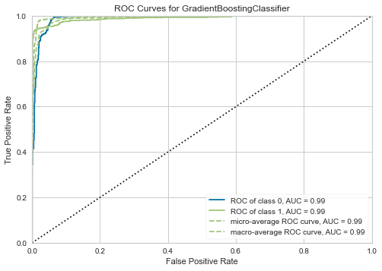
ROC AUC OF DECISION TREE CLASSIFIER.
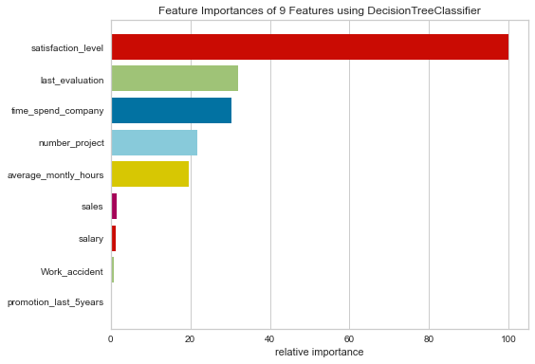
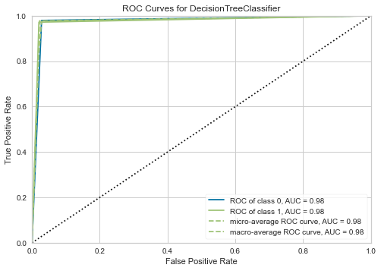

CONCLUSION.
We have successfully learned how to analyze employee attrition using machine learning models. Only with a couple of codes and a proper data set, a company can easily understand which areas needed to look after to make the workplace more comfortable for their employees and restore their human resource power for a longer period.
REFERENCE.
- Flach PA (2003) The geometry of ROC space: understanding machine learning metrics through ROC isometrics. In: Proceedings Twentieth International Conference on Machine Learning.
- Google Scholar Human Resource History.

